This is either called a portfolio, or a simple website setup. I don’t care what platform you use, as its only for a school project, and in 3 weeks, you can delete it. So put on whatever site is free that you like.

Main page



Main Header:

What got you here, Won’t get you there. Keep the perpetual pursuit of learning.

Main page picture



**Resume page**

Place File: Adam Such 510 Resume.pdf

**About me page**

Personal Brand Statement of Adam E. Such

Hi, I'm Adam

I'm an executive type to achieve goals and success,

With strong leadership, acing every challenge,

With the drive and passion to make a difference when needed,

and always.

About me picture



**Contact**:

Make a generic “fill in your name” and “message”. I don’t care about functionality, just make it look like a way to get ahold of me.

Insert Contact me picture. 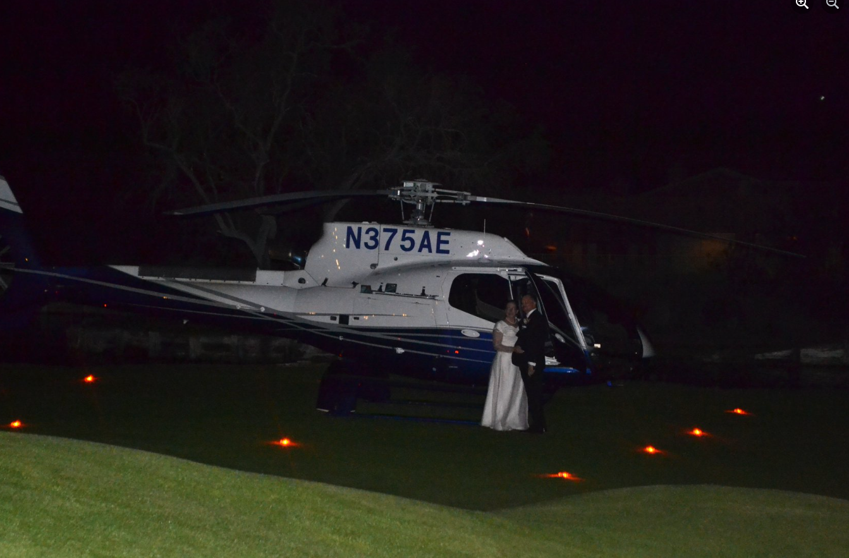

**Artifacts**

**3 main artifacts then a collection of PDFs.**

(this I’ll need to do a little more work on. I’ll send you another word doc of instructions and 3 pictures. Then I’ll draft up a little text that will go under each artifact.

**Last artifacts are PDFs.**

Make a header saying, “These artifacts demonstrate the skills and competencies learned to meet a specific program of study”.

Then upload each PDF. Either above or Below the PDF, insert text using text taken from each of the file names. If you could do a preview of the PDF, that would be great.

Here is what I am environing. 3 PDFs in a row.

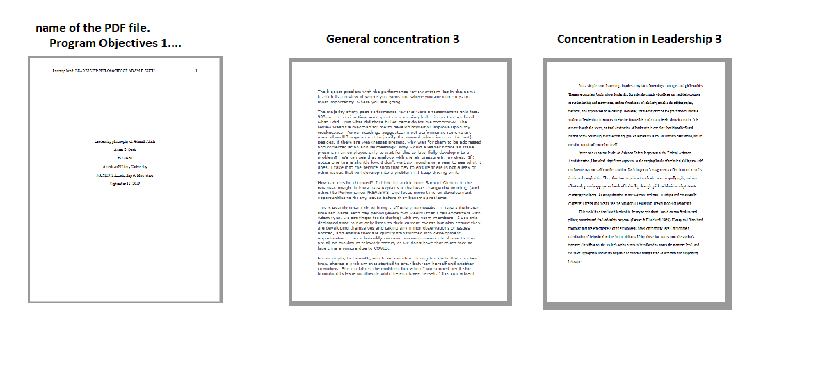

Then continue until all are there!

I hope this gives you enough to start. I’ll check in about 24 hrs. Please send what questions you have.